Paper 2 Draft #2

1. Abstract
2. Introduction/Background
3. Methods
4. Results
5. Discussion
6. Conclusion
7. References
8. Abstract
   1. Background

The Syrian conflict has dramatically changed the public health landscape of Syria since its onset in March of 2011. Indiscriminate targeting of healthcare facilities, transports, medical personnel, and patients throughout the conflict have had tremendous impact on Syria’s healthcare capacity and priorities. The Assistance Coordination Unit (ACU) has established a robust active surveillance system, known as the Emergency Warning and Response Network (EWARN), for infectious disease syndromes in opposition-held territories. This invaluable database has yet to be thoroughly studied.

* 1. Methods

The ACU relies on modified World Health Organization case definitions for the 13 syndromes covered by EWARN. We conducted a retrospective ecological time-series analysis using EWARN data on clinical case counts between January 2015 – June 2019.

* 1. Results
  2. Conclusions

1. Introduction/Background

Armed conflict and public health are invariably intertwined. Some of the effects of armed conflict on public health are direct and obvious, others more subtle.1 These impacts are exacerbated in conflicts with high civilian casualties.1,2 Many survivors of a conflict may be physically or mentally scarred for life, and the disruption of critical services and supplies, such as healthcare, education, energy, water, and food, can leave behind long-term impacts affecting future generations.1,2 War uproots families and individuals, while diverting human and financial resources away from nonmilitary purposes, creating additional obstacles to recovery even after the conflict has ended.2

Since its onset in 2011, the Syrian conflict has produced a complex humanitarian disaster, resulting in an estimated 500,000 fatalities, over 5.6 million refugees, and 6.6 million internally displaced persons3 out of an estimated pre-war population of 23 million people.4 During this period, Syria has suffered a number of health and healthcare challenges, including the reemergence of vaccine preventable diseases, such as polio and measles, targeted attacks on healthcare facilities, workers, patients, and supplies, and the disruption of public health services in opposition-held territories. These challenges, coupled with massive inflation, limited supplies, energy shortages, lack of safe transportation, the loss of vital infrastructure such as water sanitation, and the flight of over half of Syria’s physicians have led to dramatic changes in the epidemiology of infectious diseases, non-communicable diseases, and mental health issues.5

The conflict has also disrupted the public health surveillance capacity of Syria, primarily in regions that fell outside of government control, since the Syrian Ministry of Health could no longer operate in those territories. Initially, this contributed to diminished preventative services and uncoordinated or delayed response efforts in those areas because outbreaks could not be detected early enough and, even when finally detected, response efforts were uncoordinated between the various organizations involved and lacked information as to where efforts were most needed.

The Wild Polio Virus Type-1 (WPV-1) outbreak in 2013 was a motivating cause for the two separate surveillance efforts that have since been established, one covering territories controlled by the Syrian government, operated by the Ministry of Health, and one for opposition-held territories, operated the NGO called the Assistance Coordination Unit (ACU). Both surveillance systems are modeled after and supported by the WHO’s Emergency Surveillance and Response System (EWARS). The surveillance system of the Syrian MOH shares the same name, EWARS, while the surveillance system operated by the ACU is known as the Emergency Warning and Response Network (EWARN).

The ACU was started in 2013. They provide information management, project coordination, capacity building, monitoring and evaluation, and advocacy for organizations and projects aimed at assisting the Syrian people in opposition-held territories.6

The ACU had established an operational polio surveillance system by 2014; however, ACU’s methods and coverage of multiple infectious disease syndromes did not fully develop until the start of 2015. The EWARN has since continued collecting surveillance data to the present day, giving us valuable access to over 5 years of infectious disease syndrome data.

Although the ACU has collaborated and shared pieces of the EWARN data with organizations and academics in the past and continue to publish weekly and annual epidemiologic reports to the WHO, the Gaziantep Health Cluster, and in their newsletter, this data has not been fully evaluated yet. This study is the first to be granted nearly full access.

The data for this study comes exclusively from the EWARN database in collaboration with the ACU. We looked at trends in vaccine-preventable diseases (VPD) between January 2015 – June 2019 to better understand the impacts of this conflict on public health outcomes.

While several studies have sought to describe the immediate and local health impacts of the conflict, little is known about how they have shaped the epidemiology of Syrian over the course of the war, especially in territories beyond the reach of the Syrian Ministry of the Heath. There are potential opportunities for future studies to use both surveillance databases jointly, although there are systemic differences between them that would need to be addressed.7 Additionally, no studies have analyzed the relationship between documented attacks on healthcare facilities and the incidence of infectious diseases in Syria throughout the conflict, despite documentation for both.

Thus, this study hopes to contribute to our understanding of the impacts of the Syrian conflict and the relationships between health and conflict more broadly by using a uniquely robust, longitudinal dataset collected in the midst of conflict.

1. Methods

We conducted a retrospective ecological time-series analysis using infectious disease surveillance data collected primarily in northern Syria between January 1st, 2015 and July 31st, 2019 by the Early Warning and Response Network (EWARN) operated by the Assistance Coordination Unit (ACU).

Surveillance System

Alongside its other projects, the ACU maintains the EWARN, established in 2014 and modeled after the World Health Organization’s (WHO) Early Warning and Response System (EWARS).6 EWARN is an active surveillance program, in which surveillance data is periodically requested from health providers, and was designed for rapid and cost-effective implementation in humanitarian or conflict settings to improve disease outbreak detection.8–10

EWARN covers 13 diseases and conditions, selected for their potential to cause epidemics, their association with high morbidity and mortality, and the potential for intervention in Syria.8 EWARN’s objective is the early detection of outbreaks and to communicate epidemiological data with partner organizations.

EWARN’s follows a zero-reporting protocol, which distinguishes between missing cases and zero cases; if cases in a district in a given week are not reported due to some constraint or lack of coverage, it is reported as missing, distinct from districts that report zero cases for a given week. Note that cases are not laboratory confirmed, but rather meet the defined clinical and epidemiologic protocols discussed in the methods section.

Administrative Divisions

Syria is administratively divided into 14 governorates, or *muhafazat*, which are further divided into 65 districts, or *manatiq*, and 281 subdistricts, or *nawahi*. These administrative divisions have endured throughout the conflict, and are used by the Syrian government, the UN, the WHO, foreign governments, and the various NGOs operating in Syria. While the ACU shared data at the subdistrict level, limitations in population estimates for 2015-2016 compelled us to restrict this study to the district level.

Total Population

Population estimates for Syria between 2015 – 2019 were obtained from the ACU but originally were collected and distributed by the United Nations Office for the Coordination of Humanitarian Affairs (UNOCHA).11 These population estimates are conducted annually and distributed to UN agencies and other governmental and non-governmental organizations (NGOs) working on health-related concerns in Syria.

2015-2016 population estimates were conducted at the district-level, while 2017-2019 were conducted at the subdistrict-level, limiting our population-dependent statistics to the district-level despite subdistrict-level granularity of the surveillance data. Population characteristics, including age and sex, are not a part of the population data, limiting our ability to estimate attack rates for subsets of the population.

Population was estimated annually by UNOCHA, while EWARN surveillance data was collected on a weekly basis, leading to distortions in incidence. Changes in population appeared as discrete jumps at the beginning of each year. This was addressed by linearly imputing weekly population estimates to minimize artifacts in estimates of incidence and better represent change in population over time.

Study Population

The study population consisted of every outpatient presenting at a healthcare facility within the EWARN coverage area that met the conditions for one of the 14 syndromic case definitions. Cases were deidentified and aggregated by sex (male, female), age (≤4 years old, > 4 years old), and subdistrict into weekly case-counts for each syndrome by the ACU.

Opposition vs. government territory

The Syrian conflict has developed into a complex, international affair with many actors involved. It is not a conflict between two opposing sides but of many factions and proxies with competing interests.

For the purposes of this paper, however, the complex geopolitical landscape will be simplified into two categories: territories that are under the control of the Syrian government, which will be referred to as government-held territories, and those that the Syrian government is not in control over, which will be referred to as opposition-held territories.

This is a dynamic landscape that has not remained constant for any extended period throughout the conflict, and as the geopolitical realities shift, so, too, do the coverage regions of EWARN. The governorates of Damascus, Rural Damascus, and Lattakia and the districts of As-Safira, Tadmor, and Al-Fiq are not included because they have remained outside of EWARN’s coverage region for most, if not all, of the conflict. The other 11 governorates and constituent districts have been included, despite minor changes in coverage throughout the conflict. Districts that fall out of coverage are reported as having missing cases, not zero.

Case Classifications

According to the WHO, “countries are advised to use the clinical classification scheme until their programmes meet the following two criteria: low levels of measles incidence or access to a proficient measles laboratory;” after achieving these targets, the WHO recommends “a laboratory classification scheme should be used by countries in the low incidence or elimination phase.”12

ACU provides guidelines for EWARN case classifications that are updated annually.8 Cases that meet the definition for one of EWARN’s syndromes are classified as Syndromic Cases (*See Appendix for Table of Syndromic Case Classification).* A patient visit to one of the healthcare facilities within the EWARN network is documented as a consultation, and each region reports the total number of consultations along with the syndromic surveillance data each week.

|  |  |  |
| --- | --- | --- |
| Abbreviation | Clinical Syndrome | Suspected Disease |
| ABD | Acute Bloody Diarrhea | Shigellosis |
| AWD | Acute Watery Diarrhea | Cholera |
| OAD | Other Acute Diarrhea |  |
| AJS | Acute Jaundice Syndrome | Hepatitis A & E |
| ILI | Influenza-Like Illness | Influenza |
| SARI | Severe Acute Respiratory Illness | Avian Influenza A (H7N9), MERS-CoV, other |
| AFP | Acute Flaccid Paralysis | Poliomyelitis |
| MEA | Suspected Measles | Measles |
| MEN | Suspected Meningitis | Bacterial Meningitis |
| STF | Suspected Typhoid Fever | Typhoid |
| LEISH | Leishmaniasis | Cutaneous Leishmaniasis |
| UCE | Unusual Cluster of Health Events | N/A |
| UCD or UXD | Unusual Cluster of Deaths | N/A |

Data Collection

EWARN’s data management is hierarchically structured by geographic levels. Individual health facilities are at the “field level”, and data is actively collected from each center by Field Level Officers (FLOs). Each FLO is responsible for receiving weekly patient registers from the health facilities within their designated area. These registers are then submitted to District Level Officers (DLOs), who consolidate registers from each community and subdistrict within their designated district and then submit a weekly report to Central Level Officers (CLOs) at ACU’s headquarters in Gaziantep, Turkey. The CLOs then aggregate these reports and publish weekly case-counts at the district and governorate level.

The quality of the data is routinely assessed by calculating the completeness and timeliness of reporting for each district. EWARN enforces zero-reporting for the health facilities in its network to distinguish between non-reporting and true lack of cases, a crucial element for surveillance in a conflict setting where facilities or entire districts may be unable to report due to difficult circumstances.

Data was collected from January 1st, 2015 to July 31st, 2019 through active surveillance of healthcare facilities within EWARN. Population-level information was collected, including 1) locale of each case at the subdistrict-level, 2) sex of each case, 3) whether the case was younger than or older than five years of age.

Data Management and Analysis

Data was documented and shared by the organization using Microsoft Excel. The results were analyzed and visualized using R and ArcGIS. Descriptive analyses of surveillance data used characteristics of the study population, which included binary variables for age, sex, and geographic district. The χ2 test was used, with a P-value of <0.05 chosen as the threshold for significance.

Ethical Approval

This study was exempted by the University of California, Berkeley Institutional Review Board (IRB).

Results

Surveillance System

A total of 40,577,249 consultations were conducted by facilities within the EWARN during that period. Of those, 7,925,079 (19.53%) were cases that meet the criteria for one of the EWARN syndromes, while the remaining 80.47% were cases whose clinic presentation did not meet the definitions of any of the syndromes documented by EWARN. Table 1 breakdown the population characteristics of the cases. Population estimates did not capture characteristics of the entire population, thus incidence for each syndrome could not be stratified by age and sex.

|  |  |  |  |
| --- | --- | --- | --- |
| *Syndromic Cases* | **Female** | **Male** | *Total* |
| **<5 years old** | 1,591,412 (20.08%) | 1,616,073 (20.39%) | *3,207,486 (40.47%)* |
| **≥5 years old** | 2,446,487 (30.87%) | 2,271,107 (28.66%) | *4,717,593 (59.53%)* |
| *Total* | *4,037,899 (50.95%)* | *3,887,180 (49.05%)* | *7,925,079 (100%)* |

Figure 2

|  |  |  |  |
| --- | --- | --- | --- |
| **Year** | **Syndromic Consultations** | **Non-Syndromic Consultations** | **Total Consultations** |
| 2015 | 942,398 | 5,523,324 | 6,465,722 |
| 2016 | 1,839,233 | 6,457,191 | 8,296,424 |
| 2017 | 2,081,142 | 8,061,980 | 10,143,122 |
| 2018 | 2,110,946 | 8,739,335 | 10,850,281 |
| 2019 | 951,360 | 3,870,340 | 4,821,700 |
| **Total** | **7,925,079** *(19.53%)* | **32,652,170**  *(80.47%)* | **40,577,249**  *(100%)* |

Figure

Figure 3

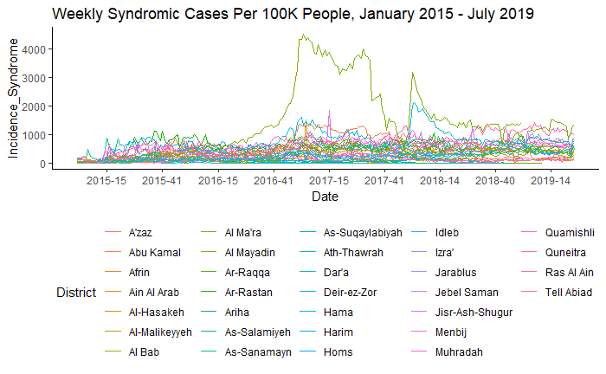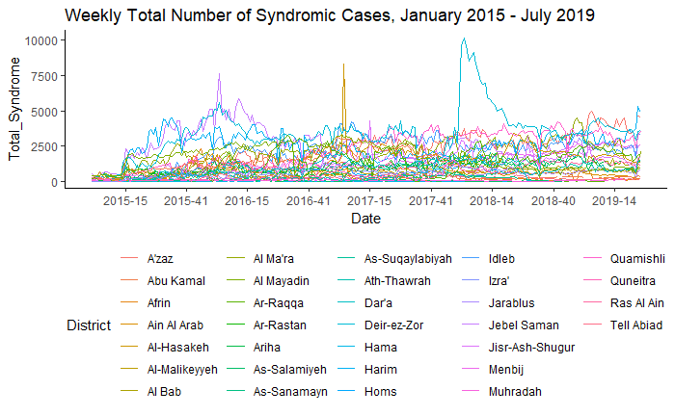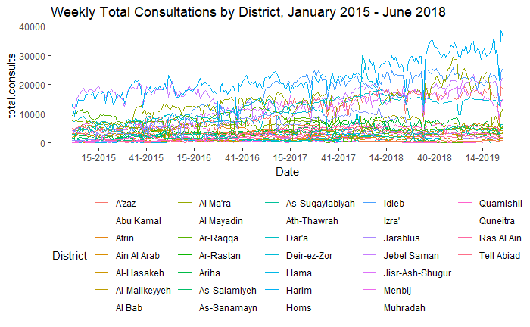

Figure 1 shows the total number of syndromic cases captured each week by EWARN between January 1st 2015 and July 31st 2019. Figure 2 shows the total incidence of all syndromic cases in that same period. Figure 3 shows the total number of consultations that were not part of the syndromic surveillance.

Measles

Measles13 is an infectious disease that does stuff.

Cases of measles were reported in every governorate except for Homs, which underwent a siege in 2017. However, certain governorates have been impacted more than others, and within governorates there are districts with more cases than others. The governorates Ar-Raqqa ad Deir-ez-Zor had the highest number of cases, followed by Idlib and Aleppo.

The greatest incidence was in Al-Mayadin and Abu Kamal Districts in the 2017 outbreak, and Ar-Raqqa, Al-Mayadin, and Deir-ez-Zor had the highest incidence in the 2018 outbreak.

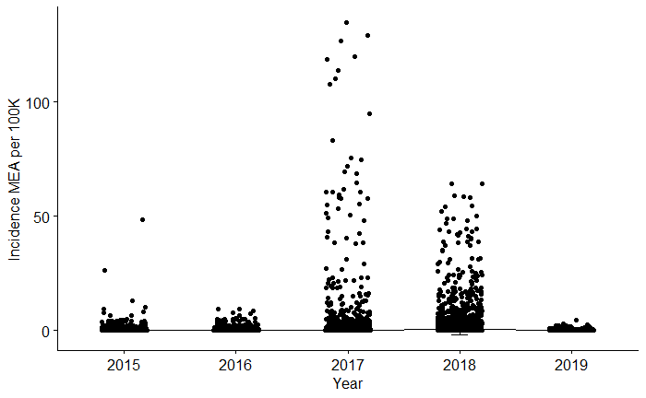Children <5 years of age were at a greater risk than the rest of the population, accounting for 60.87% of reported cases. While there was no significant difference between males and females in children (51.39% vs. 48.61% of <5 cases, p-value = 0.4158), there was a statistically significant difference between sexes in cases ≥5 years (54.47% vs. 45.43% of ≥5 cases, p-value = 0.02367) with men at a greater risk than women. It is unclear whether this was because men were more likely to present to healthcare facilities when sick or if women were more likely to have been vaccinated.

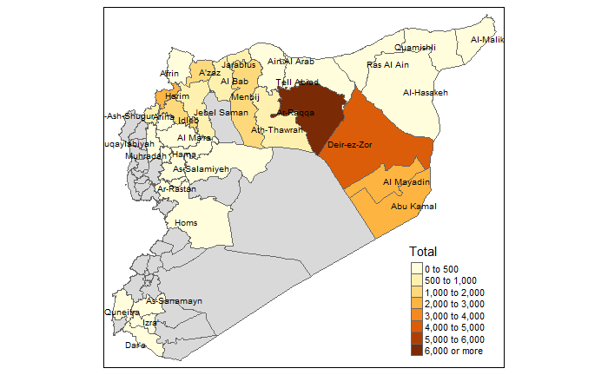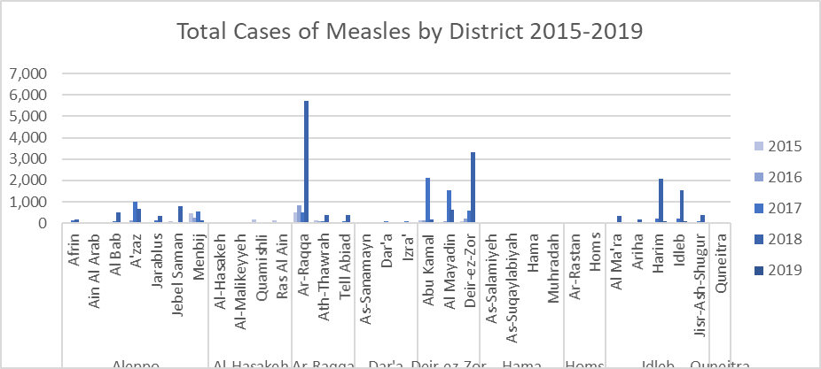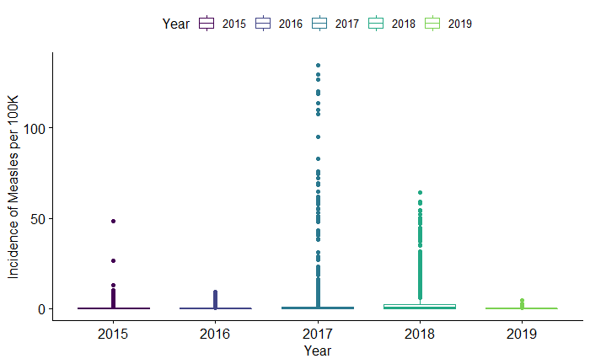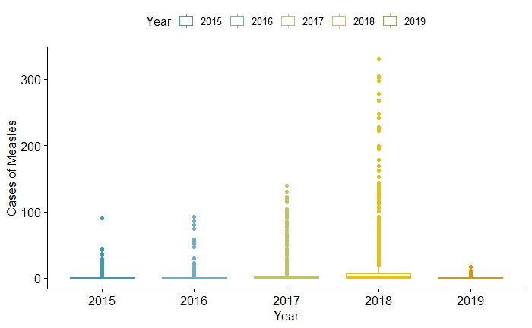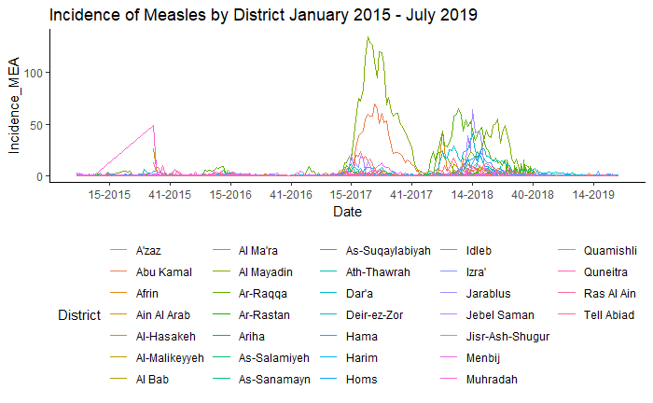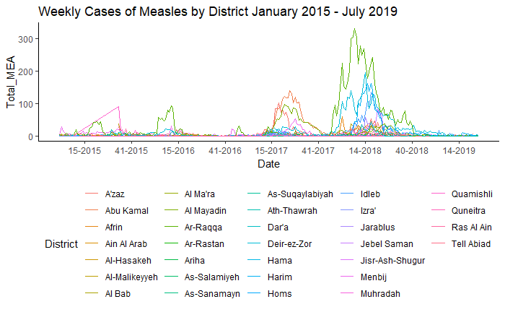

Stat Test Results List

Summary Stats for MEA incidence:

| **Year**  <fctr> | **count**  <int> | **mean**  <dbl> | **sd**  <dbl> | **median**  <dbl> | **IQR**  <dbl> |
| --- | --- | --- | --- | --- | --- |
| 2015 | 1440 | 0.3485444 | 1.6847083 | 0.0000000 | 0.2736705 |
| 2016 | 1670 | 0.2575359 | 0.7863209 | 0.0000000 | 0.1720968 |
| 2017 | 1641 | 2.7026174 | 11.7584115 | 0.0000000 | 0.7958263 |
| 2018 | 1458 | 3.4382143 | 8.2521936 | 0.4034201 | 2.4257420 |
| 2019 | 598 | 0.1546160 | 0.4069935 | 0.0000000 | 0.1161427 |

T-Tests - Assumption failed: normal distribution between two groups.

* Incidence of MEA - Male vs. Female: no diff of means, p-value = 0.1431
* Incidence of MEA - Child vs Adult: stat sig diff in menas, p-value = 2.265e-09
* Incidence of MEA 4x4 (O = Old, Y = Young, M = Male, F = Female)
  + Child Male vs. Child Female: p-value = 0.4158
  + Adult Male vs. Adult Female: p-value = 0.02637 (OM > OF ) **[WHY?]**
  + Adults Male vs Adult Male: p-value = 1.677e-07 (YM > OM)
  + Child Female vs. Adult Female: p-value = 3.103e-11 (YF > OF)

One proportion z-test - The **One proportion** **Z-test** is used to compare an observed proportion to a theoretical one, when there are only two categories. This article describes the basics of **one-proportion z-test** and provides practical examples using **R software**.

* MEA: Male vs. Female
  + Data: sum(Male.MEA, na.rm = T) out of sum(Tot.MEA, na.rm = T), null probability 0.5
  + X-squared = 81.094, df = 1, p-value < 2.2e-16
  + alternative hypothesis: true p is not equal to 0.5
  + 95 percent confidence interval:
  + 0.5202613 0.5315492
  + sample estimates:
  + p
  + 0.5259085
* MEA: Child vs. Adult
  + data: sum(Young.MEA, na.rm = T) out of sum(Tot.MEA, na.rm = T), null probability 0.5
  + X-squared = 1430.8, df = 1, p-value < 2.2e-16
  + alternative hypothesis: true p is not equal to 0.5
  + 95 percent confidence interval:
  + 0.6032457 0.6142789
  + sample estimates:
  + p
  + 0.6087762
* MEA: Syndromic Cases vs. Non-Syndromic
  + data: sum(SC_Tot, na.rm = T) out of sum(Total_Consult, na.rm = T), null probability 0.5
  + X-squared = 15068271, df = 1, p-value < 2.2e-16
  + alternative hypothesis: true p is not equal to 0.5
  + 95 percent confidence interval:
  + 0.1951865 0.1954305
  + sample estimates:
  + p
  + 0.1953084

Kruskal-Wallis rank sum test:

The Kruskal-Wallis test is a nonparametric (distribution free) test, and is used when the assumptions of one-way ANOVA are not met (normal distribution of dep var, equal variance across groups). Both the Kruskal-Wallis test and one-way ANOVA assess for significant differences on a continuous dependent variable by a categorical independent variable (with two or more groups).

Null: no sig diff in dependent variable (Incience of MEA) by the independent variable (Year, or District, or Gov). If the calculated value of Kruskal-Wallis test is greater than the critical chi-square value, then we can reject the null hypothesis and say that at least one of the samples comes from a different population.

Kruskal-Wallis rank sum test (For Incidence ~ Years)

data: Incidence_MEA by Year

Kruskal-Wallis chi-squared = 569.39, df = 4, p-value < 2.2e-16

As the p-value is less than the significance level 0.05, we can conclude that there are significant differences between the years.

Kruskal-Wallis X2 = 569.39, degrees of freedom = 4, p-value < 2.210-16

From the output of the Kruskal-Wallis test, we know that there is a significant difference between groups, but we don’t know which pairs of groups are different.

It’s possible to use the function pairwise.wilcox.test() to calculate pairwise comparisons between group levels with corrections for multiple testing:

Pairwise comparisons using Wilcoxon rank sum test (Incidence ~ Year)

data: ewarn.15.19$Incidence_MEA and ewarn.15.19$Year

2015 2016 2017 2018

2016 1.9e-05 - - -

2017 6.4e-11 < 2e-16 - -

2018 < 2e-16 < 2e-16 < 2e-16 -

2019 1.9e-05 0.27 < 2e-16 < 2e-16

P value adjustment method: BH

Years that are stat sig show diff between those two years.

|  |  |  |  |  |
| --- | --- | --- | --- | --- |
| *Pairwise Test of Incidence by Year* | **2015** | **2016** | **2017** | **2018** |
| **2016** | 1.9 10-5 | - | - | - |
| **2017** | 6.4 10-11 | < 2 10-16 | - | - |
| **2018** | < 2 10-16 | < 2 10-16 | < 2 10-16 | - |
| **2019** | 1.9 10-5 | 0.27 | < 2 10-16 | < 2 10-16 |

Alternative pairwise:

Pairwise comparisons using Dwass-Steele-Critchlow-Fligner all-pairs test

data: Incidence_MEA by Year

2015 2016 2017 2018

2016 0.00017 - - -

2017 4.5e-10 4.7e-14 - -

2018 < 2e-16 < 2e-16 5.1e-14 -

2019 0.00017 0.80640 4.6e-14 < 2e-16

P value adjustment method: single-step

-------------------------------------------------------------------------

Kruskal-Wallis rank sum test (Incidence ~ Governorate)

data: Incidence_MEA by Governorate

Kruskal-Wallis chi-squared = 1253.5, df = 8, p-value < 2.2e-16

Kruskal-Wallis X2 = 1253.5, degrees of freedom = 8, p-value < 2.210-16

Pairwise test:

|  |  |  |  |  |  |  |  |  |
| --- | --- | --- | --- | --- | --- | --- | --- | --- |
| *Pairwise Test of Incidence by Governorate* | Al-Hasakeh | Aleppo | Ar-Raqqa | Dar’a | Deir-ez-Zor | Hama | Homs | Idleb |
| Aleppo | <2 10-16 | - | - | - | - | - | - | - |
| Ar-Raqqa | <2 10-16 | 3.8 10-7 | - | - | - | - | - | - |
| Dar’a | 0.0682 | <2 10-16 | <2 10-16 | - | - | - | - | - |
| Deir-ez-Zor | <2 10-16 | <2 10-16 | 4.0 10-4 | <2 10-16 | - | - | - | - |
| Hama | 1.3 10-13 | <2 10-16 | <2 10-16 | <2 10-16 | <2 10-16 | - | - | - |
| Homs | <2 10-16 | <2 10-16 | <2 10-16 | <2 10-16 | <2 10-16 | 4.6 10-6 | - | - |
| Idleb | <2 10-16 | 0.0180 | 0.0180 | <2 10-16 | <2 10-16 | <2 10-16 | <2 10-16 | - |
| Quneitra | 0.287 | 2.1 10-11 | 8.6 10-16 | 0.0374 | <2 10-16 | 7.4 10-4 | 3.9 10-11 | <2 10-16 |

airwise comparisons using Wilcoxon rank sum test (Incidence ~ Gov)

data: ewarn.15.19$Incidence_MEA and ewarn.15.19$Governorate

Al-Hasakeh Aleppo Ar-Raqqa Dar'a Deir-ez-Zor Hama Homs Idleb

Aleppo < 2e-16 - - - - - - -

Ar-Raqqa < 2e-16 3.8e-07 - - - - - -

Dar'a 0.06821 < 2e-16 < 2e-16 - - - - -

Deir-ez-Zor < 2e-16 < 2e-16 4.0e-09 < 2e-16 - - - -

Hama 1.3e-13 < 2e-16 < 2e-16 < 2e-16 < 2e-16 - - -

Homs < 2e-16 < 2e-16 < 2e-16 < 2e-16 < 2e-16 4.6e-06 - -

Idleb < 2e-16 0.00011 0.01800 < 2e-16 < 2e-16 < 2e-16 < 2e-16 -

Quneitra 0.28675 2.1e-11 8.6e-16 0.03741 < 2e-16 0.00074 3.9e-11 < 2e-16

One-Way ANOVA

The one-way analysis of variance (ANOVA), also known as one-factor ANOVA, is an extension of independent two-samples t-test for comparing means in a situation where there are more than two groups. In one-way ANOVA, the data is organized into several groups base on one single grouping variable (also called factor variable). This tutorial describes the basic principle of the one-way ANOVA test and provides practical anova test examples in R software.

MEA.incidence.anova <- aov(Incidence_MEA ~ Year, data = ewarn.15.19)

Summary(MEA.incidence.anova)

Df Sum Sq Mean Sq F value Pr(>F)

Year 4 13349 3337 68.45 <2e-16 ***

Residuals 6779 330499 49

---

Signif. codes: 0 ‘***’ 0.001 ‘**’ 0.01 ‘*’ 0.05 ‘.’ 0.1 ‘ ’ 1

23 observations deleted due to missingness

Tukey:

Tukey multiple comparisons of means

95% family-wise confidence level

Fit: aov(formula = Incidence_MEA ~ Year, data = ewarn.15.19)

$Year

diff lwr upr p adj

2016-2015 -0.09100853 -0.77613078 0.5941137 0.9963207

2017-2015 2.35407304 1.66615345 3.0419926 0.0000000

2018-2015 3.08966986 2.38064669 3.7986930 0.0000000

2019-2015 -0.19392845 -1.12800118 0.7401443 0.9798743

2017-2016 2.44508156 1.78287356 3.1072896 0.0000000

2018-2016 3.18067839 2.49657318 3.8647836 0.0000000

2019-2016 -0.10291992 -1.01822203 0.8123822 0.9980781

2018-2017 0.73559682 0.04869014 1.4225035 0.0287667

2019-2017 -2.54800148 -3.46539933 -1.6306036 0.0000000

2019-2018 -3.28359831 -4.21692532 -2.3502713 0.0000000

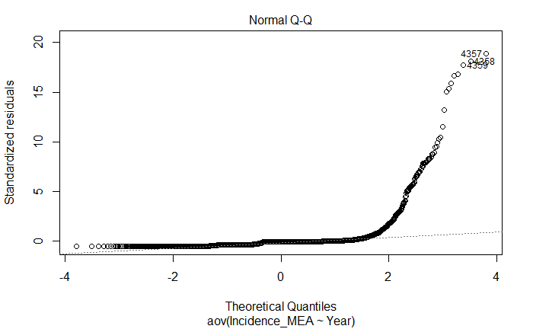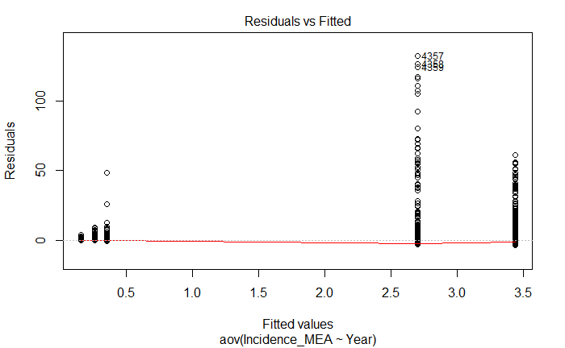

Pairwise comparisons using t tests with pooled SD

data: ewarn.15.19$Incidence_MEA and ewarn.15.19$Year

2015 2016 2017 2018

2016 0.759 - - -

2017 < 2e-16 < 2e-16 - -

2018 < 2e-16 < 2e-16 0.005 -

2019 0.714 0.759 6.6e-14 < 2e-16

P value adjustment method: BH

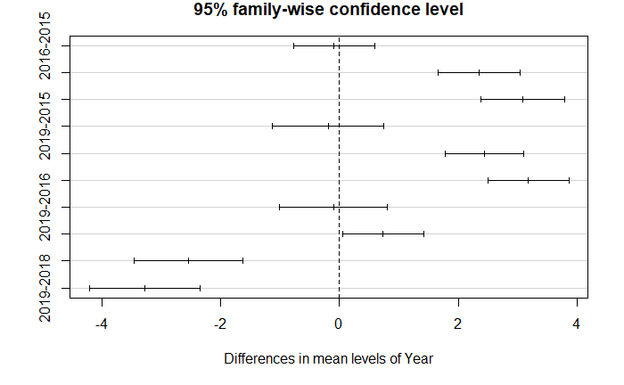

Problem: Variance assumption is invalid according to the Levene Test.

Levene's Test for Homogeneity of Variance (center = median)

Df F value Pr(>F)

group 4 68.183 < 2.2e-16 ***

6779

---

Signif. codes: 0 ‘***’ 0.001 ‘**’ 0.01 ‘*’ 0.05 ‘.’ 0.1 ‘ ’ 1

____________

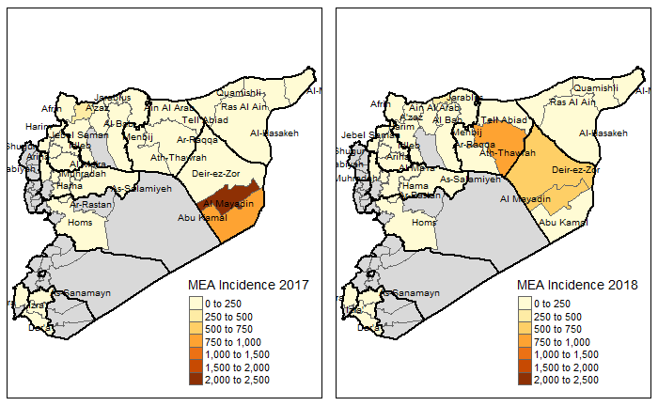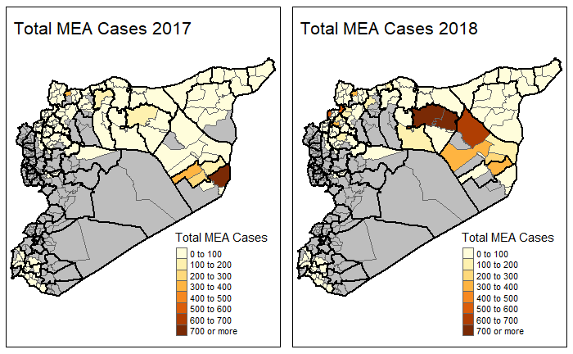

Discussion

The global burden of measles was estimated to be 6.7 million cases in 2017, with 173,330 cases reported to the WHO. In 2018, 353,236 cases reported to the WHO, with estimates set to be released in November 2019.15,16

The outbreaks of 2017 and 2018 were the largest since Syria first eliminated measles in 1999.17 No outbreaks were reported in 2019, likely due to a combination of vaccination efforts in response to previous outbreaks and the acquired immunity of the most susceptible populations as a consequence of those outbreaks.

The outbreaks follow a mostly biannual outbreak trend. The largest outbreaks of 2017 were concentrated in Abu Kamal and Al Mayadin Districts in the Deir-ez-Zor governorate, while the largest outbreaks in 2018 were concentrated in Al-Mayadin and Deir-ez-Zor districts in Deir-ez-Zor governorate and Ar-Raqqa district of Ar-Raqqa Governorate. Districts with high incidence of measles in 2017 experienced a reduction in incidence the following year, suggesting a reduction in the at-risk population due to acquired immunity. In 2017 incidence peaked towards the end of June and beginning of July, while in 2018 incidence peaked around end of March. The 2018 outbreak had a more gradual increase in incidence from the beginning of January until the end of August, compared to sharp increase in incidence in mid-March and rapid decline that tapered off until early October. The seasonality of measles is typically lost as elimination of measles in a given population is approached, which may provide an important epidemiologic marker to monitor for as vaccination efforts are continued.14

The measles outbreak in 2017 was largely confined three districts: Abu Kamal and Al-Mayadin, two neighboring districts in the east of the country in the Deir-ez-Zor Governorate, and a relatively minor outbreak in A’zaz, in the north of the Aleppo governorate. In 2018, the outbreak spread farther west, affecting the districts of Al-Mayadin and Deir-ez-Zor in the Deir-ez-Zor governorate and Ath-Thawrah in the Ar-Raqqa governorate, with another minor outbreak in Jarablus in the north of the Aleppo governorate.

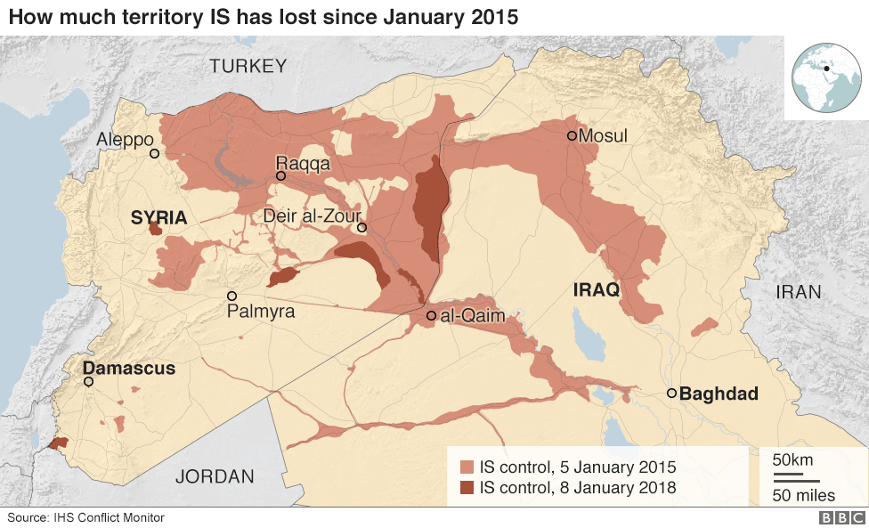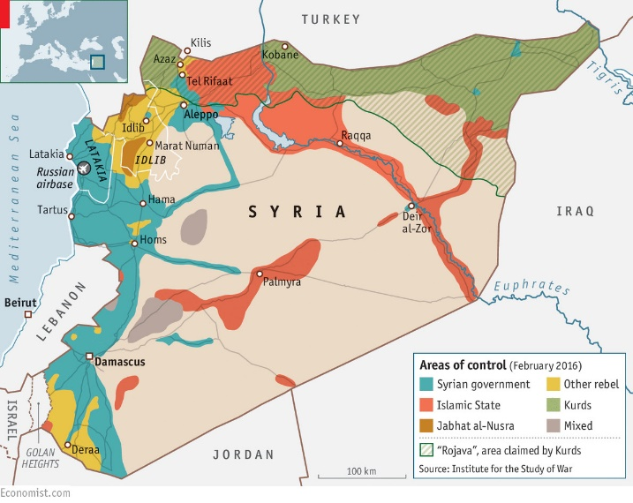March 4, 2013, the governorate of Ar-Raqqa fell to the Syrian opposition, with several groups, including Al-Nusra Front and what was then known as the Islamic State in Iraq (ISI) operating there. ISI attempted to merge with Al-Nusra front in April 2013, and changed its name to the Islamic State in Iraq and Syria (ISIS), known in Arabic as *Daesh*, but the latter rejected, allying themselves with Al-Qaeda instead. In January of 2014, *Daesh* takes over Ar-Raqqa and declares it as its new capital. In June of that year, *Daesh* seizes the border between Iraq and Deir-ez-Zor. By 2015, *Daesh* had reached its maximum extent, with control of the governorates of Deir-ez-Zor and Ar-Raqqa, and parts of Homs, Hama, and Al-Hasekeh, and eastern Aleppo.

The populated regions of Ar-Raqqa and Deir-ez-Zor fell to various opposition groups in the spring of 2013 and were primarily under *Daesh* control from January 2014 – August 2017. These areas were largely inaccessible to many aid organizations and ACU’s laboratory surveillance efforts were restricted, although Daesh did comply with the ACU’s polio campaigns in the areas and infectious disease reports were still able to make it through, albeit discretely. Deir-ez-Zor shares a border with Iraq, and was a gateway for many fighters to enter Syria during the early stages of the conflict. The 2013 polio outbreak occurred in Deir-ez-Zor, suggesting that routine vaccination and adequate sanitation had fallen even before then.

ACU’s EWARN has proven itself to be a robust surveillance system and is often the only source for infectious disease data from opposition territories.18 The data that they have collected and distributed have helped direct clinical practice within Syria, informed vaccination and other intervention efforts of many NGOs, improved triaging of limited resources, facilitated the mobilization of support from donor organizations, and provided access to precious information to the international community in a timely fashion. Paradoxically, information on the spread of certain infectious diseases within the EWARN coverage regions may be more accessible now than ever before.

The system has remained stable despite the conflict, able to detect the large annual surges of suspected typhoid fever cases in the fall and deviations from the minute yet consistent baseline incidence of acute flaccid paralysis that trigger investigations for polio. By reporting the timeliness and completeness of each district’s reports and utilizing a zero-reporting protocol, gaps in surveillance data can be easily identified, and unreported information can be distinguished from the true absence of cases.

Limitations

There are many limitations to consider for this study, given the context of conflict in which the data was collected. This study uses ecological data, and can only make associations at the population level. We did not have access to data on weekly incidence rates for measles in Syria prior to the conflict or between the start of the conflict in March 2011 and when ACU began publishing their data in January 2015. Population estimates were also difficult to accurately assess; UNOCHA used different methods between 2015-2016 than between 2017-2019 population estimates, and it is unclear how this may have influenced population estimates. Population in Syria has been dynamic throughout the course of the war, especially in areas most affected by health. This not only further complicates accurate population estimates to match with weekly disease reports, but it also raises the question whether changes in case counts within a given district are due to factors directly affecting that district or factors that impact neighboring districts. For example, if District A loses its only hospital, and people within District A have to travel to District B to seek care, we will see a change in incidence in District B even though this is because of access to care in District A. Thus, while this study is not able to make causal inferences about the etiology of these outbreaks, we can conclude that these outbreaks did take place, that segments of the Syrian population have become vulnerable to vaccine-preventable diseases, and that it is possible to collect valuable, accurate, and reasonably consistent data in real-time during a conflict for response, advocacy, and research purposes.

Conclusion

Although we cannot deduce which policies or actors were directly responsible for the two measles outbreaks, we can surmise that the regions affected the outbreaks were heavily involved in the conflict, they were limited in their access to aid organizations or government services, and that these factors led to decreased vaccination rates and thus increased vulnerability to a measles epidemic. Further studies relating the severity of the conflict or attacks on healthcare facilities should be conducted to better assess their relationship with vaccine preventable diseases.

* Underestimated incidence by WHO
* Due to no mass immunizations (Due to ISIS?)
* Due to severity of attacks?
* Immunization data?
  + Routine or mass campaign
  + Are either disrupted by attack?
* Measles modeling articles to see how long after immune declines you get outbreak, and what level it has to decline to
  + Complicated by migrations, is it higher risk to be attacked or be next to a district that gets attacked?
  + In literature, look up mobility effects on measles outbreak
* Do we only see these outbreaks in 2017 because that is when Daesh left?

Limitations

Many.

Conflict of Interest

No conflicts of interests to declare.

Appendix

|  |  |  |  |  |  |
| --- | --- | --- | --- | --- | --- |
| Cases of Measles | <5 Male | <5 Female | >5 Male | >5 Female | Total Cases |
| Aleppo Total: | **1663** | **1512** | **1232** | **1045** | **5452** |
| Afrin | 25 | 48 | 127 | 96 | 296 |
| Ain Al Arab | 26 | 21 | 18 | 9 | 74 |
| Al Bab | 161 | 169 | 187 | 150 | 667 |
| A'zaz | 607 | 527 | 325 | 324 | 1783 |
| Jarablus | 146 | 147 | 89 | 109 | 491 |
| Jebel Saman | 255 | 217 | 169 | 134 | 775 |
| Menbij | 443 | 383 | 317 | 223 | 1366 |
| Al-Hasakeh Total: | **195** | **174** | **128** | **103** | **600** |
| Al-Hasakeh | 23 | 18 | 8 | 10 | 59 |
| Al-Malikeyyeh | 28 | 22 | 21 | 27 | 98 |
| Quamishli | 96 | 85 | 57 | 26 | 264 |
| Ras Al Ain | 48 | 49 | 42 | 40 | 179 |
| Ar-Raqqa Total: | **2226** | **2180** | **1937** | **1682** | **8025** |
| Ar-Raqqa | 1843 | 1820 | 1743 | 1537 | 6943 |
| Ath-Thawrah | 254 | 230 | 101 | 85 | 670 |
| Tell Abiad | 129 | 130 | 93 | 60 | 412 |
| Dar'a Total: | **85** | **114** | **35** | **33** | **267** |
| As-Sanamayn | 3 | 4 | 1 | 0 | 8 |
| Dar'a | 39 | 64 | 19 | 23 | 145 |
| Izra' | 43 | 46 | 15 | 10 | 114 |
| Deir-ez-Zor Total: | **2601** | **2608** | **1760** | **1336** | **8305** |
| Abu Kamal | 751 | 815 | 533 | 354 | 2453 |
| Al Mayadin | 658 | 765 | 446 | 288 | 2157 |
| Deir-ez-Zor | 1192 | 1028 | 781 | 694 | 3695 |
| Hama Total: | **28** | **31** | **21** | **10** | **90** |
| As-Salamiyeh | 8 | 3 | 3 | 2 | 16 |
| As-Suqaylabiyah | 7 | 16 | 14 | 7 | 44 |
| Hama | 9 | 10 | 4 | 1 | 24 |
| Muhradah | 4 | 2 | 0 | 0 | 6 |
| Homs Total: | **0** | **0** | **1** | **0** | **1** |
| Ar-Rastan | 0 | 0 | 1 | 0 | 1 |
| Homs | 0 | 0 | 0 | 0 | 0 |
| Idleb Total: | **1745** | **1478** | **876** | **818** | **4917** |
| Al Ma'ra | 128 | 117 | 66 | 55 | 366 |
| Ariha | 92 | 74 | 24 | 34 | 224 |
| Harim | 757 | 647 | 390 | 379 | 2173 |
| Idleb | 595 | 481 | 324 | 264 | 1664 |
| Jisr-Ash-Shugur | 173 | 159 | 72 | 86 | 490 |
| Quneitra Total: | **5** | **15** | **17** | **13** | **50** |
| Quneitra | 5 | 15 | 17 | 13 | 50 |
| *Grand Total:* | **8,548** | **8,112** | **6,007** | **5,040** | **27,707** |

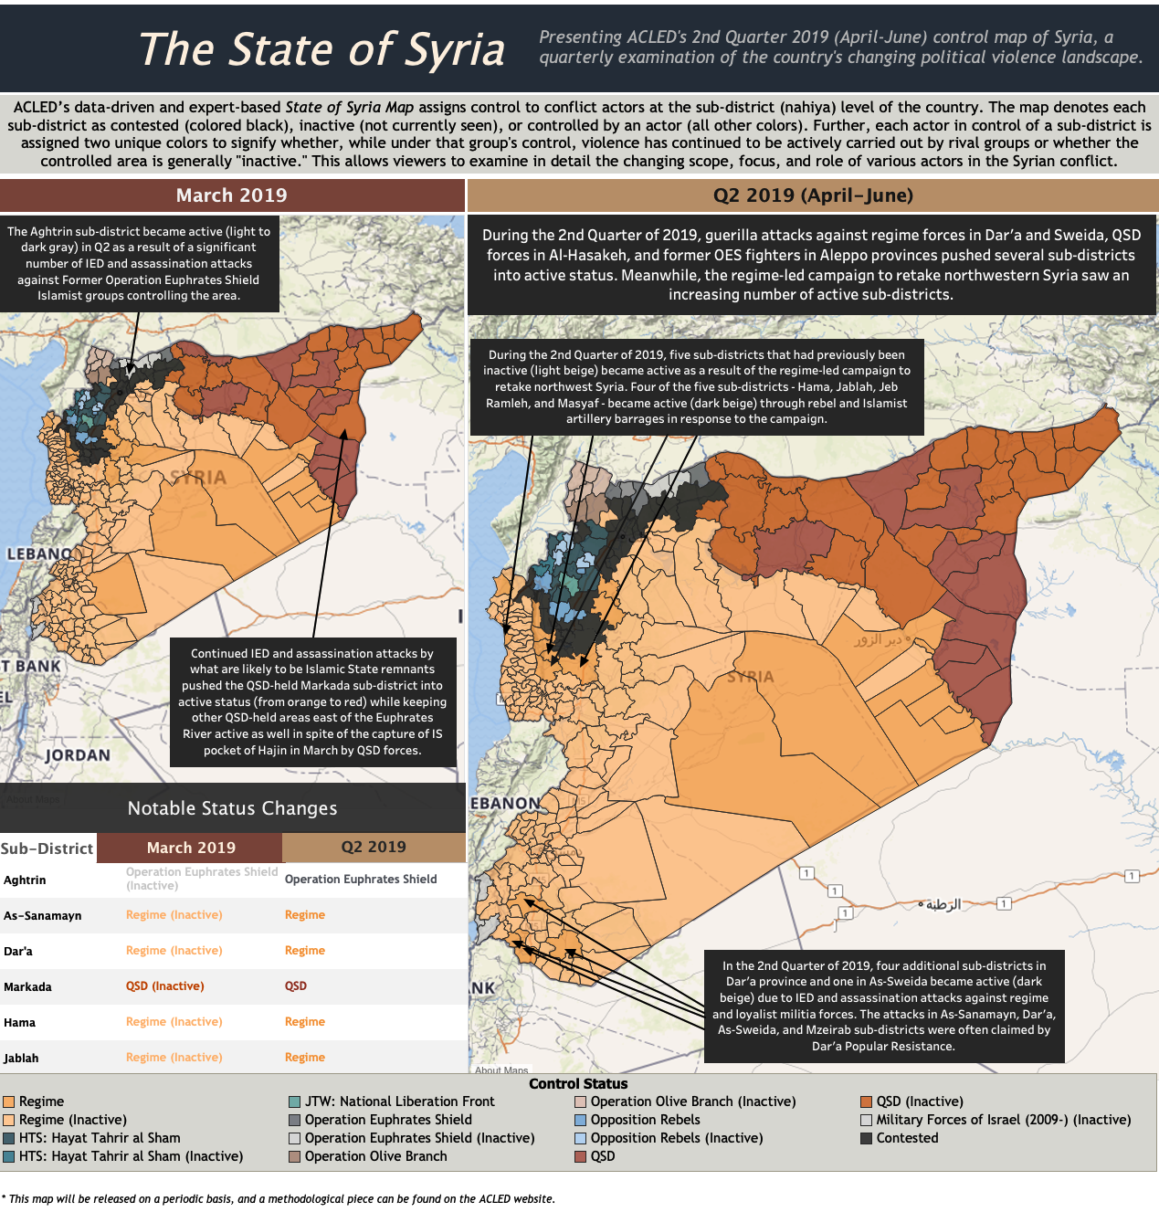

References

1. Levy BS, Sidel VW. *War and Public Health*.; 2009. doi:10.1093/acprof:oso/9780195311181.001.0001

2. Levy BS, Sidel V. Documenting the Effects of Armed Conflict on Population Health. *Ssrn*. 2016. doi:10.1146/annurev-publhealth-032315-021913

3. UNHCR. Situation in Syria Regional Refugee Response. 15 August 2019. https://data2.unhcr.org/en/situations/syria. Published 2019.

4. Agency CI. The World Factbook: Syria. The World Factbook. https://www.cia.gov/library/publications/the-world-factbook/geos/sy.html. Published 2019.

5. Sparrow A. Syria ’ s Assault on Doctors. 2013:1-7.

6. ACU. Assistance Coordination Unit: Identity. https://www.acu-sy.org/en/identity/. Published 2019. Accessed August 20, 2019.

7. Ismail SA, Abbara A, Collin SM, et al. Communicable disease surveillance and control in the context of conflict and mass displacement in Syria. *Int J Infect Dis*. 2016;47:15-22. doi:10.1016/j.ijid.2016.05.011

8. ACU. *EWARN Guidelines*. Gaziantep, Turkey; 2017. https://www.acu-sy.org/en/guidelines-ewarn-guidelines/.

9. Syrian Arab Republic, WHO. WHO: Early Warning and Response System in Syria. http://www.emro.who.int/syr/publications-other/ewars-weekly-bulletin.html. Published 2019.

10. CDC. Help and Hope for Syrian Refugees: The Many Ways We Take Action in a Crisis. Division of Global Health Protection. https://www.cdc.gov/globalhealth/healthprotection/fieldupdates/summer-2016/syrian-crisis-timeline.html. Accessed September 14, 2019.

11. UNOCHA. UN Office for the Coordination of Humanitarian Affairs: Syrian Arab Republic. https://www.unocha.org/syrian-arab-republic/about-ocha-syria. Published 2019.

12. *Overview of Vaccine Preventable Diseases Surveillance Principles*. Geneva, Switzerland; 2018. doi:10.1071/NB03028

13. Moss WJ. Measles. *Lancet (London, England)*. 2017;390(10111):2490-2502. doi:10.1016/S0140-6736(17)31463-0

14. Durrheim DN, Crowcroft NS, Strebel PM. Measles – The epidemiology of elimination. *Vaccine*. 2014;32(51):6880-6883. doi:10.1016/j.vaccine.2014.10.061

15. WHO. Measles: Immunization , Vaccines and Biologicals Measles. https://www.who.int/immunization/monitoring_surveillance/burden/vpd/surveillance_type/active/measles/en/. Published 2018.

16. WHO: New measles surveillance data from WHO. *WHO*. 2019. https://www.who.int/immunization/newsroom/new-measles-data-august-2019/en/. Accessed September 14, 2019.

17. WHO | Immunization Country Profile. https://apps.who.int/immunization_monitoring/globalsummary/incidences?c=SYR. Accessed September 14, 2019.

18. CDC. CDC Global Health - Infographics - Early Warning Alert And Response Network Put The Brakes On Deadly Diseases. https://www.cdc.gov/globalhealth/infographics/global-health-security/ewarn.htm. Accessed September 14, 2019.